HORLEY TOWN COUNCIL  Joan Walsh  Town Clerk  Council Offices, 92 Albert Road  Horley, Surrey RH6 7HZ  Tel: 01293 784765  info@horleysurrey-tc.gov.uk  www.horleysurrey-tc.gov.uk | 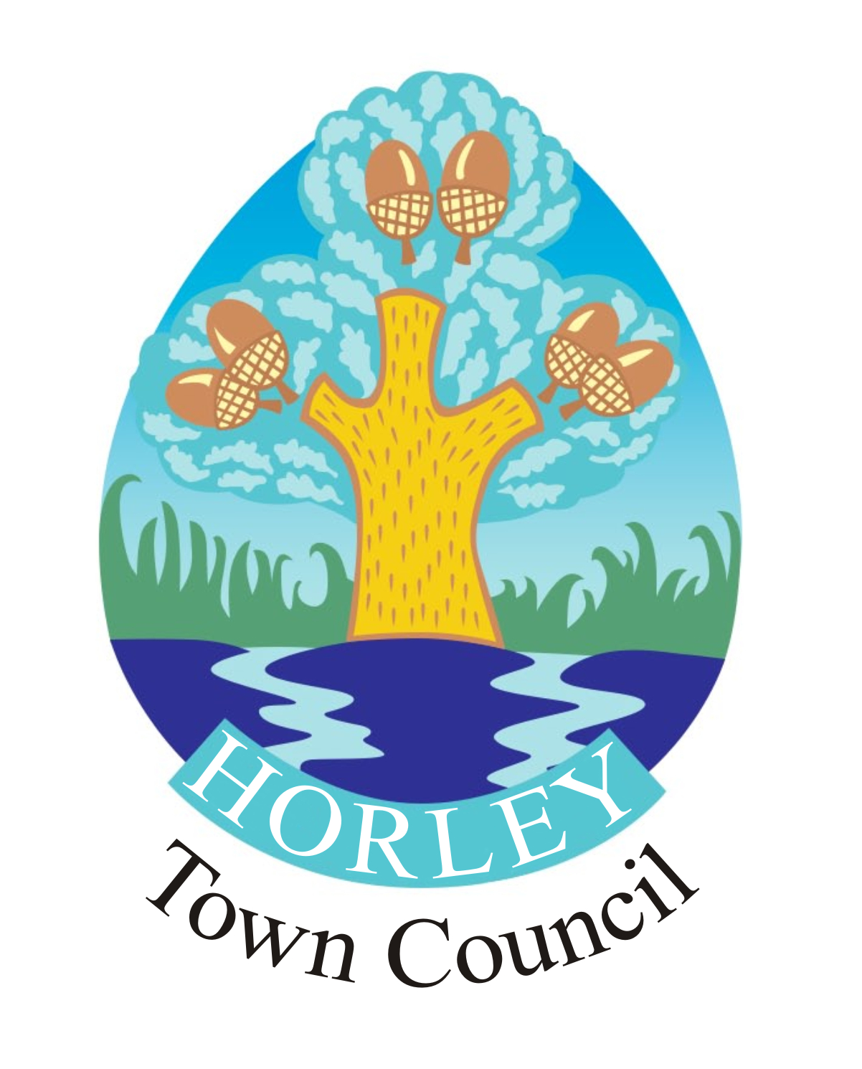
PLEASE NOTE CHANGE OF DATE

The people of Horley are invited to attend the
HORLEY TOWN MEETING
to be held in the Edmonds Community Hall,
Albert Rooms, Albert Road, Horley on Thursday 16 May 2019 at 7.30 pm.
(Light refreshments will be available from 7.00 pm)

IN THE CHAIR – Cllr David Powell, Chairman of Horley Town Council

1 To receive apologies for absence.

2 To confirm and sign the Minutes of the Horley Town Meeting held on Friday 27 April 2018.

3 To receive the unaudited accounts of Smith's Charity for the year ending
28 February 2019.

4 Horley Churchyards – to receive a report from a representative of the Churchyards Committee.

5 Horley Edmonds Community Fund – to receive an update.

6 To receive the Annual Report of Horley Town Council.

7 To receive the report of the Chairman of Horley Town Council.

8 To receive the reports of the following Committees:
i) Leisure & Amenities Committee
ii) Planning & Development Committee
iii) Finance & General Purposes Committee

9 To consider any relevant Town matters, resolutions as to which to have been submitted in writing by Thursday 9 May 2019.

10 To receive any updates on matters raised at previous Residents’ Forum Meetings and to consider any ongoing concerns.

11 To receive a presentation on Air Quality Monitoring in Horley from Reigate & Banstead officer Leon Hibbs, followed by a Question and Answer Session.

Date of Next Meeting – 24 April 2020 (provisional)
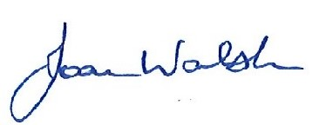
Town Clerk

Dated 5 March 2019

