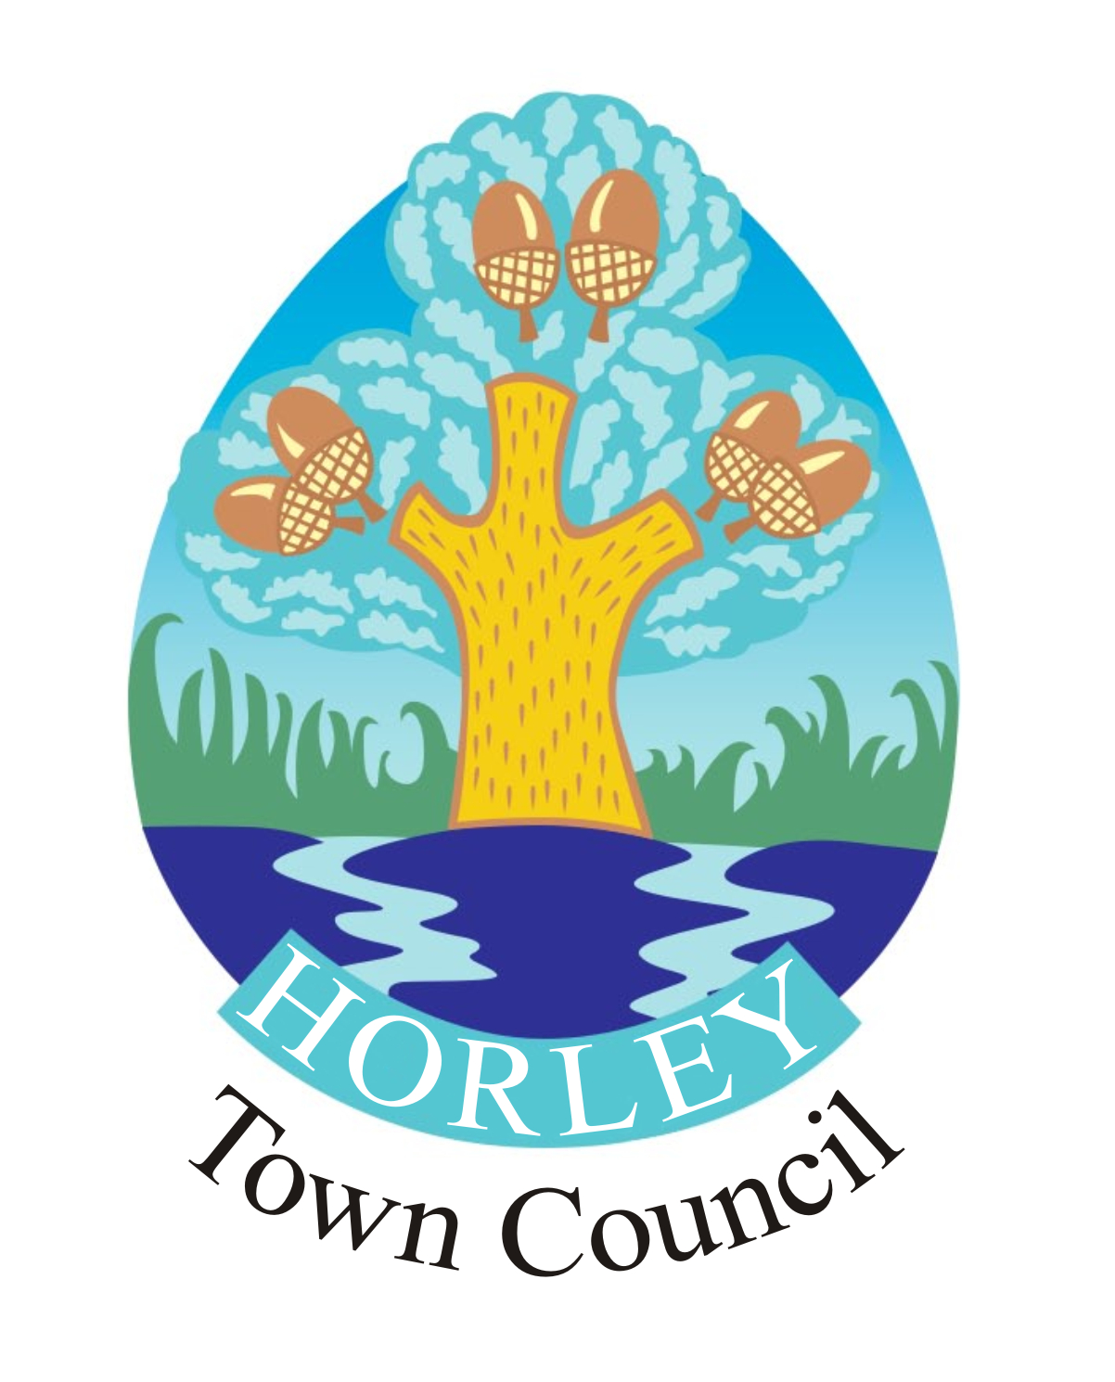 | 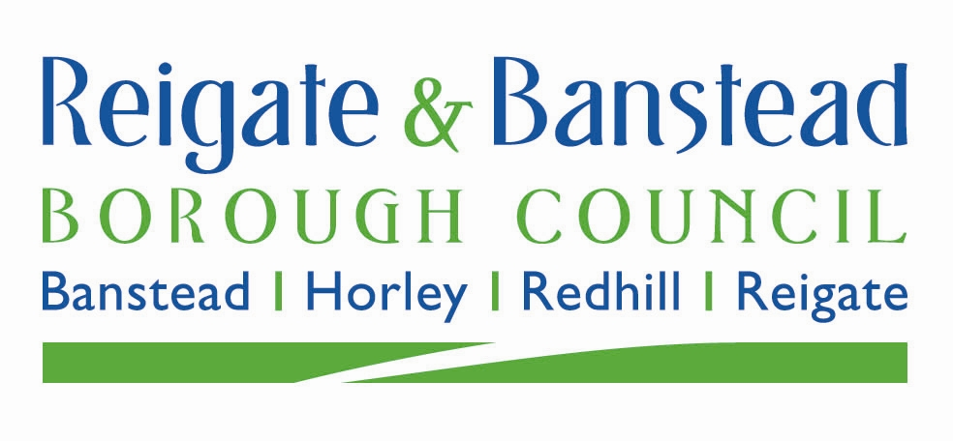 |  | 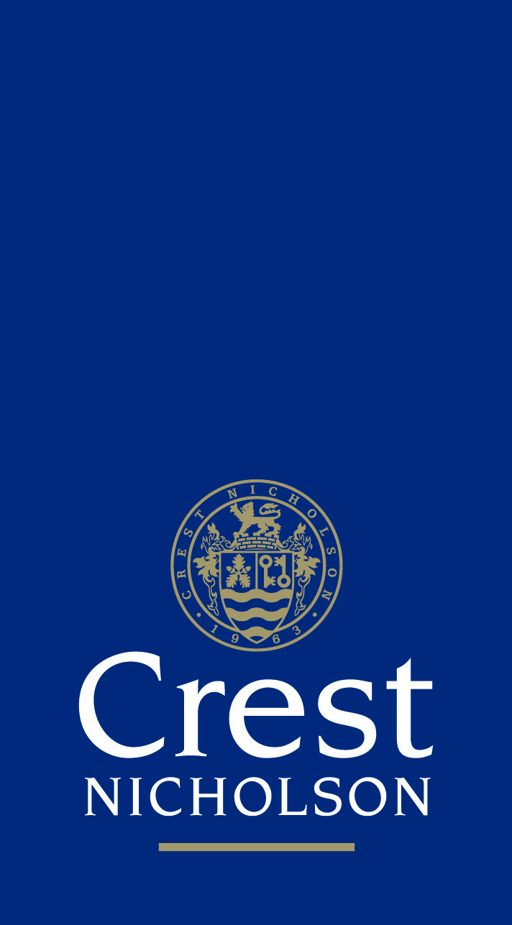 |  |  | 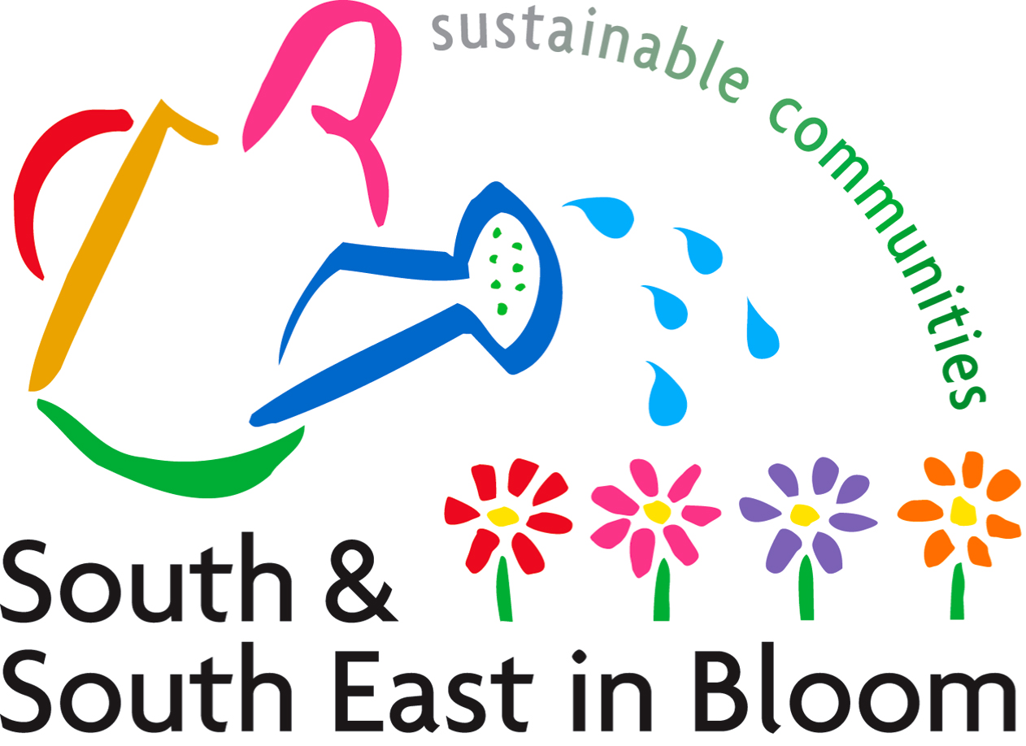

Horley in Bloom Photographic Competition 2017

Entry Details:

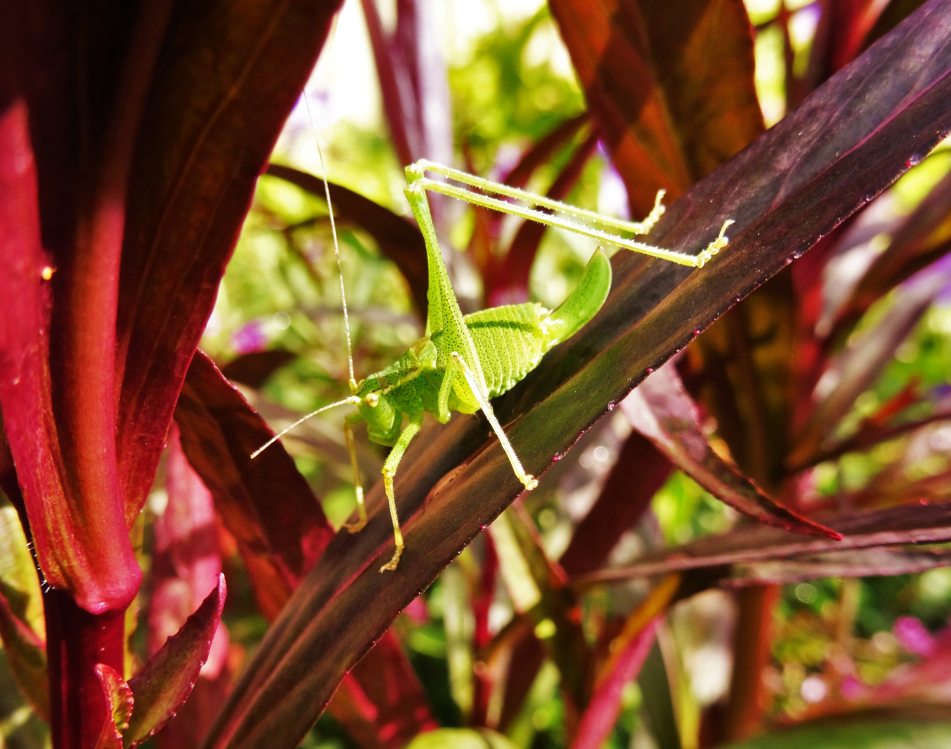
Three Categories:
Hanging Basket / Plants
Garden Scene
Street View, Park or Countryside Scene
(All photos to be taken in the Horley Area)
Age Groups:
Key Stage 1 (Years 1 and 2)
Key Stage 2 (Years 3, 4, 5 & 6)
Key Stage 3 (Years 7,8 & 9)
Key Stage 4 (Years 10 and 11)
Adult (16+)

Competition open to both residents and non-residents of Horley

Prints to be no smaller than 5 x 7 inches and ideally no larger than 8x10 inches.

A maximum of three entries per category to be allowed per entrant.

Prints to be mounted on card if the entrant so wishes. (This does produce a better result)

Full details to be entered on the back of every entry (name, address, phone no, email and class entered)

Prints to be sent / delivered to the Town Council Offices, 92 Albert Road, Horley RH6 7HZ

Entries may be submitted electronically, however we cannot guarantee the quality of the printed photograph

Closing Date – Monday 21 August 2017

Judging to take place in late August / Early September at the Town Council Offices (Reception to follow for all entrants on the same day.)

Prizes to be presented at the Horley in Bloom Awards Evening, due to take place on Friday 29 September at the Regent Hall, Albert Road, Horley RH6 7JA

Any queries please telephone: 01293 784765 or e mail town.clerk@horleytown.com

