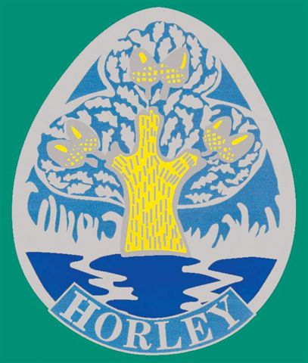 | 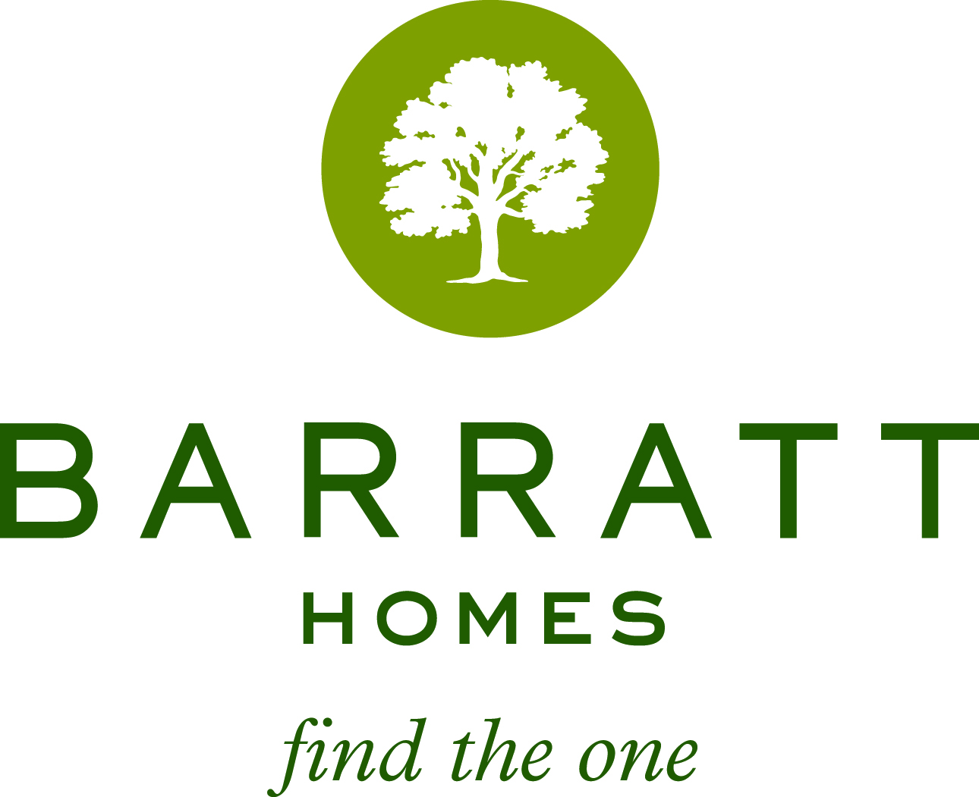 | 

Horley in Bloom Photographic Competition 2015 Sponsored by Barratt Homes
Entry Details

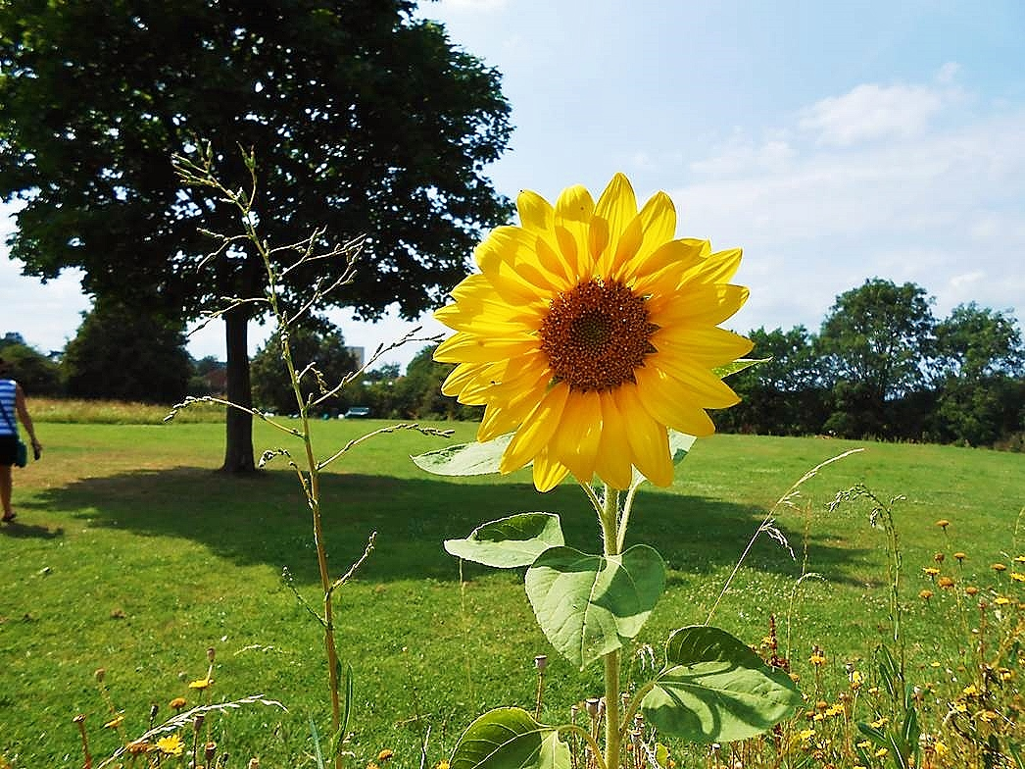
Three Categories:
Hanging Basket / Plants
Garden Scene
Street View, Park or Countryside Scene
(All photos to be taken in the Horley Area)
Age Groups:
Key Stage 1 (Years 1 and 2)
Key Stage 2 (Years 3, 4, 5 & 6)
Key Stage 3 (Years 7,8 & 9)
Key Stage 4 (Years 10 and 11)
Adult (16+)

Competition open to both residents and non-residents of Horley

Prints to be no smaller than 5 x 7 inches and no larger than 8x10 inches.

A maximum of three entries per category to be allowed per entrant.

Prints to be mounted on card if the entrant so wishes.

Full details to be entered on the back of every entry (name, address, phone no, email and class entered)

Prints to be sent / delivered to the Town Council Offices, 92 Albert Road, Horley RH6 7HZ

Entries may be submitted electronically, however we cannot guarantee the quality of the printed photograph

Closing Date – NOW EXTENDED TO FRIDAY 21 AUGUST!!

Judging to take place in late August / Early September

Very attractive cash prizes for the winners!

Prizes to be presented at the Horley in Bloom Awards Evening, due to take place on Friday 25 September at the Regent Hall, Albert Road, Horley RH6 7JA

Any queries please telephone: 01293 784765 or e mail town.clerk@zen.co.uk

