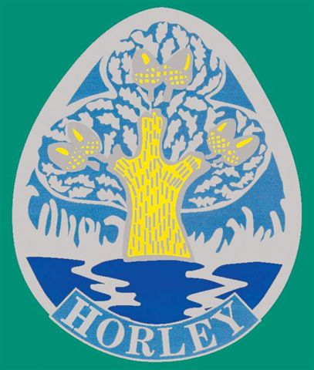 |  | 
Horley in Bloom Entry Form 2014
Entries invited from the Parish of Horley & Hookwood
Schools from Horley and Charlwood are invited to enter

Category (Please tick as appropriate)

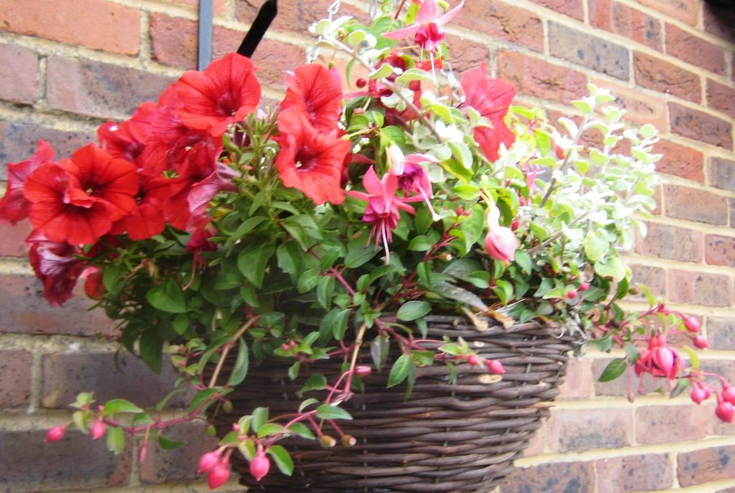
Residential (Front Garden)
Residential (Back Garden)
Residential Flat
Schools
Community
Hanging Basket / Planter
Allotments
Public Houses
Commercial (includes guesthouses)
Newcomer *
* Judges will make an award to the overall best newcomer. Please tick this box in addition to the categories entered, if applicable.

Judges will also make an award for the garden which, in their opinion, represents the best example of a Cottage Garden.

Judges will be keen to see evidence of gardens being watered with recycled water, as well as the composting of green waste. Additional marks may be awarded, where plants have been grown from seed / cuttings. (Judging criteria available upon request.) Judges’ comments available once results published.

Title: ____ _ First Name: Surname: _______

House Number & Road: ______________

Post Code: _____Telephone Number: ________

Have plants been grown from seed? ____________________________________

email: _______________________________ Signed: _______________________

* Don’t forget our Photographic Competition – See separate entry details

Closing date: Monday 30 June 2014

Judging will take place in early July. The exact judging dates will be announced nearer the time and will be advertised on our web site. Results will appear in the local press and on the Town Council website. Please make a note in your diaries that the Awards Evening will take place on: Friday 26 September 2014 at 7.30 pm at the Regent Hall, Albert Road, Horley RH6 7JA

Return your entries to: Horley Town Council, 92 Albert Road, Horley, RH6 7HZ.
You may also enter via our web site www.horleysurrey-tc.gov.uk
Any queries please telephone: 01293 784765 or e mail town.clerk@zen.co.uk

